DATE ______________ P.O.#  BUYER 

IF IN U.S.A., PROVIDE TAX I.D.# 

**INVENTORY CLEARANCE OF LEFTOVER CAMLOCKS**

|  |  |  |  |  |  |  |
| --- | --- | --- | --- | --- | --- | --- |
| **QTY.** | | **REF.** | **DESCRIPTION** | | **UNIT $** | **TOTAL CAD $** |
|  | | **230S-KA** | High security Pagoda cylinder-miniature | **MINI CAMLOCK**  **10mm (3/8”), KEYED ALIKE**  **10 /BOX** | **3.95** |  |
|  | | **171-KD** |  | **CAMLOCK, TUBULAR KEY,**  **KEYED DIFFERENT, KEY REMOVABLE IN LOCKED POSITION ONLY, 10 /BOX** | **3.95** |  |
|  | |  |  |  |  |  |
|  | **FREE SHIPPING** (ORDERS OVER $99) | | | | |  |

***SHIPPING ADDRESS:*** IF FREIGHT COLLECT, or ACCT. #

*COMPANY  PHONE* 

*ADDRESS*  *EMAIL* 

*CITY*  *PROV / STATE*  *POSTAL / ZIP CODE* 



  

**CREDIT CARD IS PAYMENT POLICY.**

NAME ON CARD 

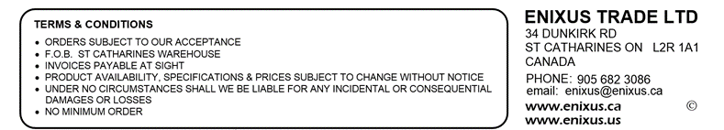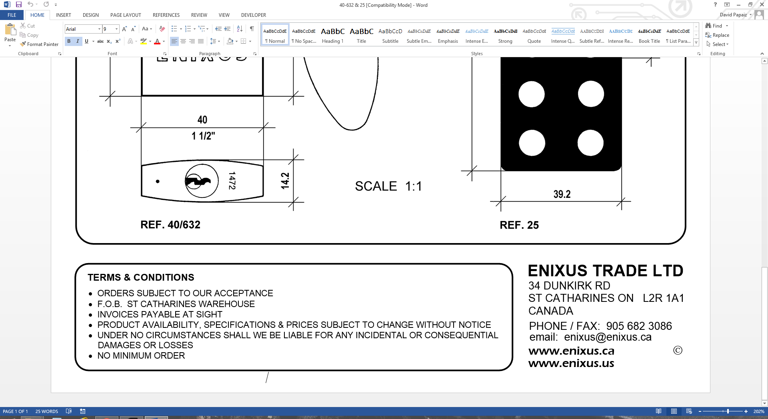 CARD NUMBER  EXPIRY DATE 